 | Year 11 Earth and Environmental Science  Task 6: End of Unit

Name:  Due Date: | Teacher: | Score: /60

This test has two sections __ multiple choice questions and __ short answer questions.

1. Which of the following has the is the least hardness according to Moh’s scale?
a) Diamond
b) Quartz
c) Talc
d) Fluorite

2. Which of the following is NOT a known lustre?
a) Pearly
b) Waxy
c) Glassy
d) Shiny

3. Which of the rocks below is an example of an igneous rock?
a) Obsidian
b) Marble
c) Gneiss
d) Limestone

4. Which of the following is the correct?
a) Intrusive igneous rocks have small crystals
b) Intrusive igneous rocks have large crystals
c) Extrusive igneous rocks have no crystals
d) Extrusive igneous rocks have large crystals

5. Which of the following is an example of a metamorphic rock?
a) Marble
b) Siltstone
c) Granite
d) Gabbro

6. Which of the following describes a convergent plate boundary?
a) Two tectonic plates pulling apart
b) Two tectonic plates sliding past one another
c) Two tectonic plates colliding against one another
d) Two tectonic plates created from pressure from magma below
7. Which landform would you expect with a divergent plate boundary between two ocean plates?
a) Volcanoes
b) Deep ocean trench
c) Rift Valley
d) Mid ocean trench

8. Which of the following is NOT an agent of erosion
a) Temperature
b) Wind
c) Water
d) Ice

9. Which is the largest layer in the Earth’s interior?
a) Crust
b) Mantle
c) Outer core
d) Inner core

10. What conditions are needed for the formation of a metamorphic rock?
a) Heat
b) Fire
c) Magma
d) Heat and Pressure

11. In the image below, what type of weathering has occurred?

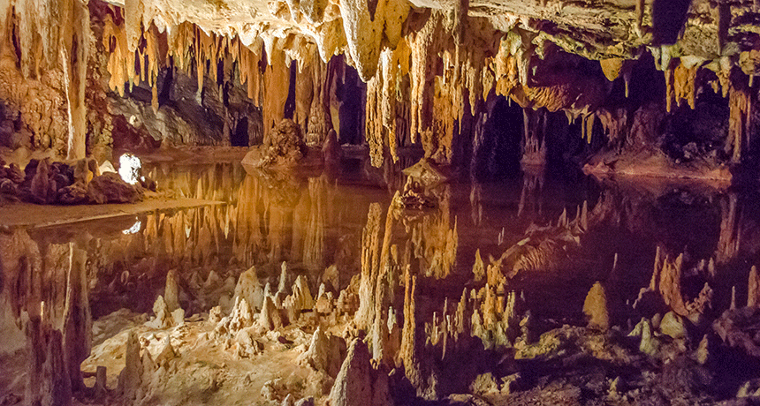
a) Oxidation
b) Solution and carbonation
c) Frost wedging
d) Biological weathering

12. Which of the following in NOT an example of biological weathering?
a) Plants growing through rock cracks
b) Humans mining
c) Animals burrowing within a rock
d) Rocks breaking apart due to temperature change

13. Which method of soil conservation describes leaving 30% of crop on the surface during peak soil erosion periods?
a) Conservation tillage
b) Cover crops
c) Alley cropping
d) Strip cropping

14. Which is the correct definition for porosity?
a) Ability of soils to transmit water
b) How easily water flows through the soil profile
c) Size of the gaps between soil particles
d) how easily soils are eroded

15. Which of the following soils would have the smallest porosity?
a) Silt
b) Clay
c) Clay loam
d) Sand

SHORT ANSWER SECTION

16. Below is an image of a soil conservation method. Please name the method and describe why this is used to preserve soils. (3 marks)
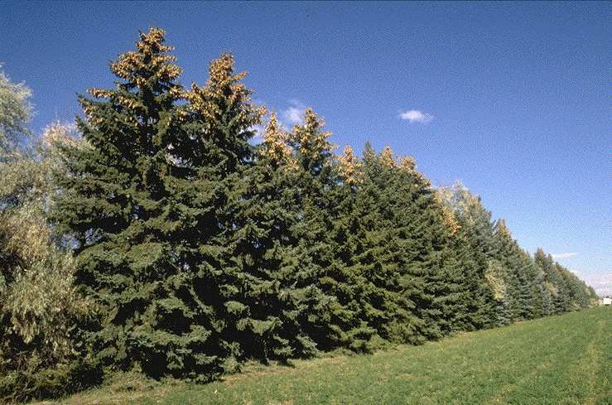
_________________________________________________________ _________________________________________________________ _________________________________________________________ _________________________________________________________ _________________________________________________________ _________________________________________________________

18. Name the two types of weathering that can occur (2 marks)
_________________________________________________________________
_________________________________________________________________

19. Describe the formation of Igneous intrusive rocks (4 marks)
______________________________________________________________________________________________________________________________________________________________________________________________________________________________________________________________________________________________________________________________

20. Label the diagram below with the following terms compaction, deposition, cementation, weathering and transport (5 marks)
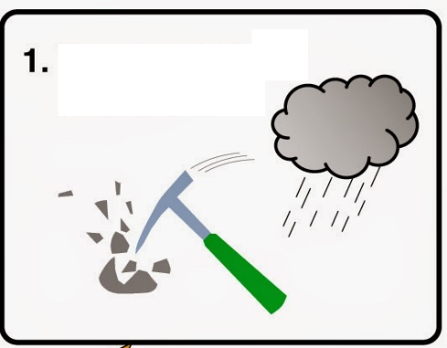
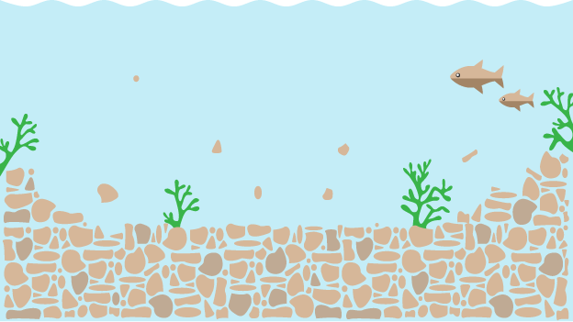
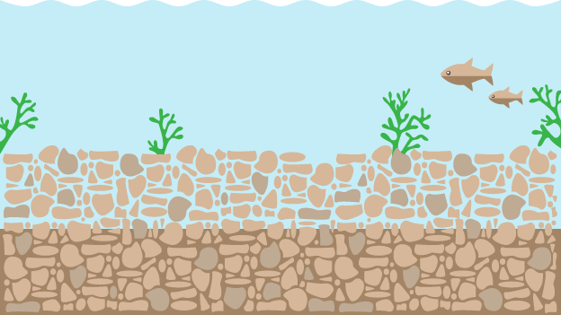
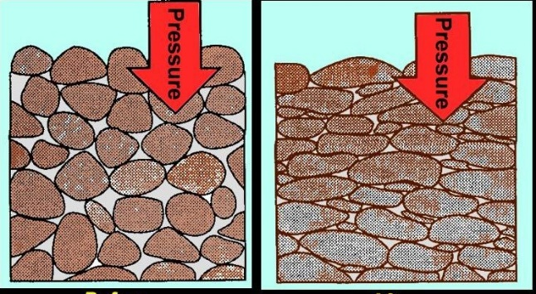
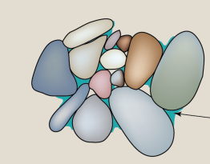

21. Label the following soils in the soil texture triangle below (5 marks)
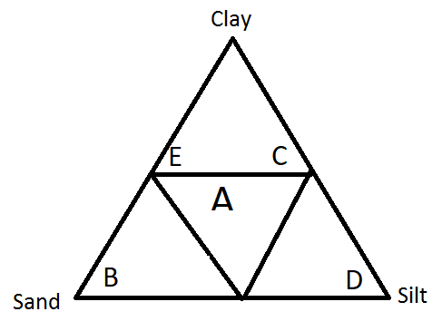
A _______________________________
B _______________________________
C _______________________________
D _______________________________
E _______________________________

22. Discuss what the diagram below (3 marks)
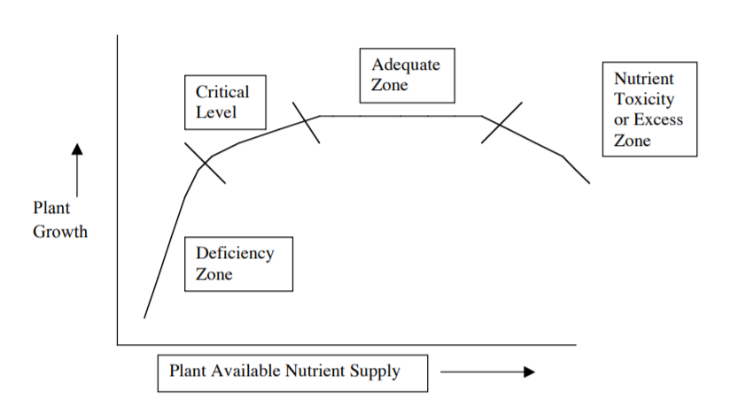

______________________________________________________________________________________________________________________________________________________________________________________________________________________________________________________________________________________________________________________________
__________________________________________________________________________________________________________

23. What are the three primary sources of nutrients for plant growth? (3 marks)
__________________________________________________
__________________________________________________
__________________________________________________

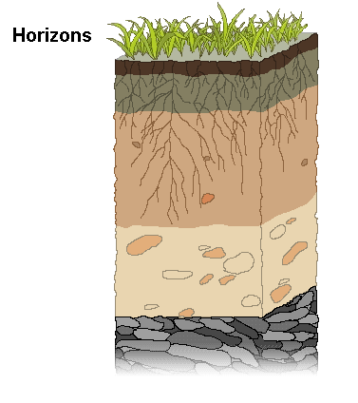
24. Label the following diagram of the soil profile (5 marks)

GRAPHING
Students were investigating the water holding capacity of different soil types. They collected the data in the table below. As they boiled the water they measured the weight of the soil at 2 minutes intervals
Time | Soil A (g) | Soil B (g) | Soil C (g)
0 | 54.2 | 64.3 | 58.6
2 | 53.9 | 63.8 | 58.6
4 | 53.1 | 63.1 | 58.4
6 | 58.5 | 62.1 | 58.2
8 | 57.9 | 61.4 | 58.1
10 | 57.5 | 61.0 | 58.0
12 | 57.1 | 59.5 | 57.9
14 | 56.9 | 59.2 | 57.9
16 | 56.8 | 59.1 | 57.8
18 | 56.8 | 59.1 | 57.8
20 | 56.7 | 59.0 | 57.8

a) Graph the following data on the grid attached (5 marks)
b) List the amount of water lost for each soil type (3 marks)
______________________________________________________________________________________________________________________________________________________________________________________________________________________________________________________________________________________________________________________________
c) Based on the above data describe what type of soil texture you would expect to see for each of the soil types (3 marks)

__________________________________________________________________________________________________________________________

ADD IN QUESTION MATCH SCIENTIST and CONTRIBUTION TO PLATE TECTONICS
ADD IN QUESTION FORMATION HAWAII

